Video No. P 1701
Slide : 1
God Image
Housewarming Imvitation

Slide : 2
Couple Photographs
Name
Mrs. & Mr. Tejveer Rajput
Invites you to visit their new house

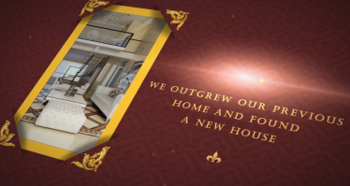 | Slide : 3  Home Photograph  We outgrew our previous home and found a new house

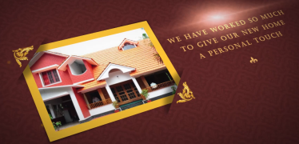 | Slide : 4  Home Photograph  We have worked so much to give your new home a personal touch.

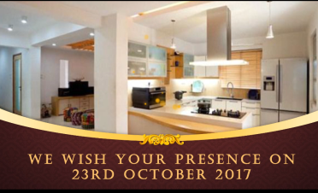 | Slide : 5  Home Photographs  We wish your presence  on 23rd October 2017

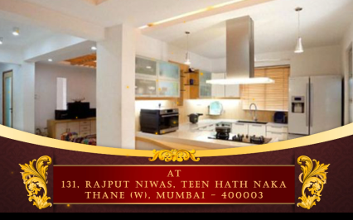 | Slide : 6  Home Photograph  Address  At 131, Rajput Niwas, Teen Hath Naka, Thane (W), Mumbai- 03.

Video Music :
Same As or If any choice please send me Youtub Link by mail and Mention in form also.
Link :

