Video No. P 1607

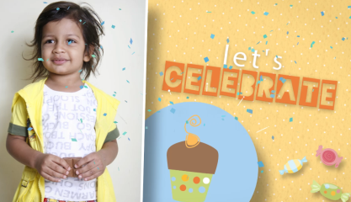 | Slide : 1  Girl or Boy Solo Photograph  (High Resolution : Minimum 800 x 800 pixel)  Please rename your photograph with the name of Slide 1  Send your photograph by E-mail  Let’s Celebrate

Slide : 2
Girl or Boy Solo Photograph
(High Resolution : Minimum 800 x 800 pixel)
Please rename your photograph with the name of Slide 1
Send your photograph by E-mail

Slide : 3
Girl or Boy Solo Photograph
(High Resolution : Minimum 800 x 800 pixel)
Please rename your photograph with the name of Slide 1
Send your photograph by E-mail

Boy or girl name
Jairaj

Is turning 5!

Slide : 4
Girl or Boy solo Photograph
(High Resolution : Minimum 800 x 800 pixel)
Please rename your photograph with the name of Slide 1
Send your photograph by E-mail

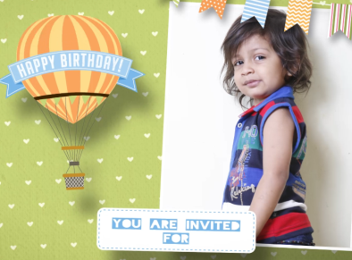 | Slide : 5  Girl or Boy solo Photograph  (High Resolution : Minimum 800 x 800 pixel)  Please rename your photograph with the name of Slide 1  Send your photograph by E-mail  You are invited for

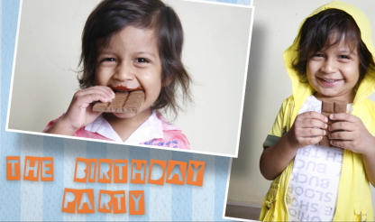 | Slide : 6  Girl or Boy solo Photograph  (High Resolution : Minimum 800 x 800 pixel)  Please rename your photograph with the name of Slide 1  Send your photograph by E-mail  The Birthday party

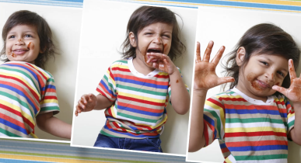 | Slide : 7  Girl or Boy 5 Photograph  (High Resolution : Minimum 800 x 800 pixel)  Please rename your photograph with the name of Slide 1  Send your photograph by E-mail

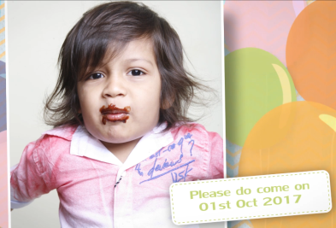 | Slide : 8  Girl or Boy 1 Photograph  (High Resolution : Minimum 800 x 800 pixel)  Please rename your photograph with the name of Slide 1  Send your photograph by E-mail  Please do come on  01st oct 2017

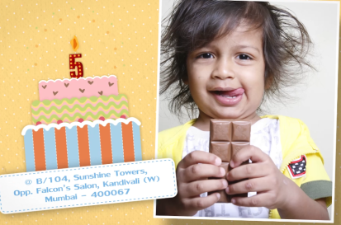 | Slide : 9  Girl or Boy 1 Photograph  (High Resolution : Minimum 800 x 800 pixel)  Please rename your photograph with the name of Slide 1  Send your photograph by E-mail  Venue  B/104, Sunshine Towers, Opp. Falcon’s Salon, Kandivali (W), Mumbai – 400 067.

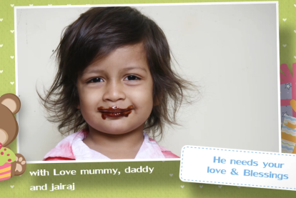 | Slide : 10  Girl or Boy 1 Photograph  (High Resolution : Minimum 800 x 800 pixel)  Please rename your photograph with the name of Slide 1  Send your photograph by E-mail  He needs your love & Blessings  With Love  Mummy, Daddy and Jairaj

Video Music :
Same As or If any choice please send me Youtub Link by mail and Mention in form also.
Link :

