Video No. P 1604

Slide : 1
Birthday Invitation of
Karishma
Year
5

Slide : 2
Boy or Girl Solo Photograph
(High Resolution : Minimum 800 x 800 pixel)
Please rename your photograph with the name of Slide 1
Send your photograph by E-mail

It’s time for some Fun

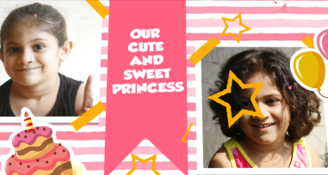 | Slide : 3  Boy or Girl 2 Solo Photograph  (High Resolution : Minimum 800 x 800 pixel)  Please rename your photograph with the name of Slide 1  Send your photograph by E-mail  Our cute and Sweet Princess

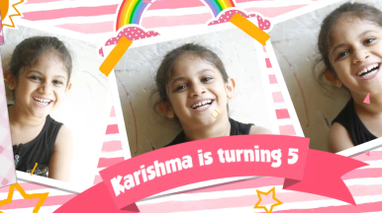 | Slide : 4  Boy or Girl 3 Solo Photograph  (High Resolution : Minimum 800 x 800 pixel)  Please rename your photograph with the name of Slide 1  Send your photograph by E-mail  Karishma is turning 5

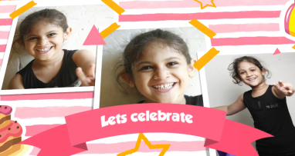 | Slide : 5  Boy or Girl 3 Solo Photograph  (High Resolution : Minimum 800 x 800 pixel)  Please rename your photograph with the name of Slide 1  Send your photograph by E-mail  Lets Celebrate

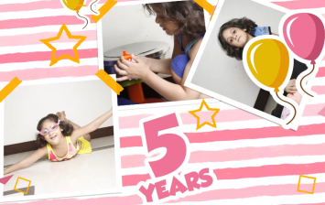 | Slide : 6  Boy or Girl 3 Solo Photograph  (High Resolution : Minimum 800 x 800 pixel)  Please rename your photograph with the name of Slide 1  Send your photograph by E-mail  5 years

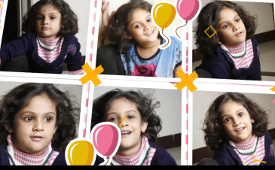 | Slide : 7  Boy or Girl 6 Solo Photograph  (High Resolution : Minimum 800 x 800 pixel)  Please rename your photograph with the name of Slide 1  Send your photograph by E-mail

Slide : 8
Date
19th November 2017
7.00 pm onwards

Venue
At A/506, Tejas Building, Near Rajwada Hotel, Jodhpur, Rajasthan

Video Music :
Same As or If any choice please send me Youtub Link by mail and Mention in form also.
Link :

