Video No. P 1603

Slide : 1
Birthday Invitation of
Abhimanyu

Slide : 2
Boy or Girl Solo Photograph
(High Resolution : Minimum 800 x 800 pixel)
Please rename your photograph with the name of Slide 1
Send your photograph by E-mail

It’s time for Cake & Fun

Slide : 3
Boy or Girl Solo Photograph
(High Resolution : Minimum 800 x 800 pixel)
Please rename your photograph with the name of Slide 1
Send your photograph by E-mail

He is turning (No of year)
5

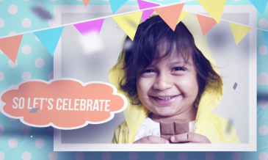 | Slide : 4  Boy or Girl Solo Photograph  (High Resolution : Minimum 800 x 800 pixel)  Please rename your photograph with the name of Slide 1  Send your photograph by E-mail  So lets Celebrate

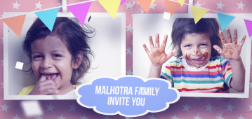 | Slide : 5  Boy or Girl 2 Solo Photograph  (High Resolution : Minimum 800 x 800 pixel)  Please rename your photograph with the name of Slide 1  Send your photograph by E-mail  Family name  Malhotra Family  Invite you

Slide : 6
Boy or Girl Solo Photograph
(High Resolution : Minimum 800 x 800 pixel)
Please rename your photograph with the name of Slide 1
Send your photograph by E-mail

Slide : 7
Boy or Girl Solo Photograph
(High Resolution : Minimum 800 x 800 pixel)
Please rename your photograph with the name of Slide 1
Send your photograph by E-mail

To the Birthday Party

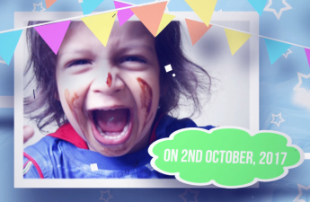 | Slide : 8  Boy or Girl Solo Photograph  (High Resolution : Minimum 800 x 800 pixel)  Please rename your photograph with the name of Slide 1  Send your photograph by E-mail  Date  On 2nd october 2017

Slide : 9
Venue
At Royal Palms
Sunder nagar, Chincholi,
Malad, Mumbai – 57.

Video Music :
Same As or If any choice please send me Youtub Link by mail and Mention in form also.
Link :

