Video No. P 1602

Please Mail 10 solo photos of you child for this video
(High Resolution : Minimum 800 x 800 pixel)
Please rename your photograph with the name of Slide 1
Send your photograph by E-mail

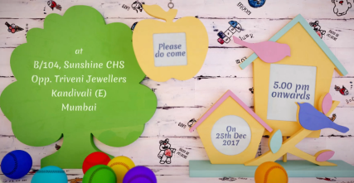 | Slide : last  Please do come  Venue  B/104, Sunshine CHS, Opp. Triveni Jewellers, Kandivali (E), Mumbai.  Time  5.00 pm onwards  Date  On 25th Dec. 2017

Video Music :
Same As or If any choice please send me Youtub Link by mail and Mention in form also.
Link :

