Video No. P1502
Slide No. 1
A New Beginning
For the Proud Parents-To-Be

Slide No. 2
Love, Joy and Wonderful Dreams

Slide No. 3
The best gift ever is on it’s way

Slide No. 4
All the sweet things a baby brings

Slide No. 5 (Mother Photograph)
(High Resolution : Minimum 800 x 800 pixel)
Please rename your photograph with the name of Slide 1
Send your photograph by E-mail

Slide No. 6 (Mother Photograph)
(High Resolution : Minimum 800 x 800 pixel)
Please rename your photograph with the name of Slide 1
Send your photograph by E-mail

So Let’s celebrate it’s arrival day

Slide No. 7 (Mother Photograph)
(High Resolution : Minimum 800 x 800 pixel)
Please rename your photograph with the name of Slide 1
Send your photograph by E-mail

Slide No. 8 (Couple Photograph & Mother name)
(High Resolution : Minimum 800 x 800 pixel)
Please rename your photograph with the name of Slide 1
Send your photograph by E-mail

(Mother name) baby Shower
Divya’s

Slide No. 9 (Couple Photograph & Mother name)
(High Resolution : Minimum 800 x 800 pixel)
Please rename your photograph with the name of Slide 1
Send your photograph by E-mail

(Mother name) baby Shower
Divya’s

(If you want to add other pic instated of couple photo can be possible.)

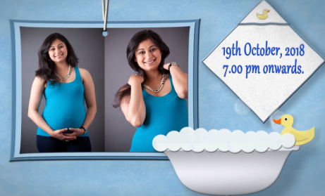 | Slide No. 10 (Mother Photograph & Function Date & Time)  (High Resolution : Minimum 800 x 800 pixel)  Please rename your photograph with the name of Slide 1  Send your photograph by E-mail  Function Date & Time  19th oct.2018, 7.00 pm onwards

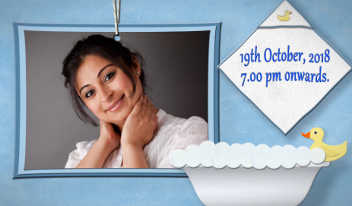 | Slide No. 11 (Mother Photograph & Function Date & Time)  (High Resolution : Minimum 800 x 800 pixel)  Please rename your photograph with the name of Slide 1  Send your photograph by E-mail  Function Date & Time  19th oct.2018, 7.00 pm onwards

Slide No. 12 Venue Address

Venue (At residence)
B/10, Sunshine Apartment, Opp. Hakim’s Salon, kandivali (E), Mumbai .

Video Music :
Same As or If any choice please send me Youtub Link by mail and Mention in form also.
Link :
https://www.youtube.com/watch?v=nIhijSP3MBc

