Video No. P1501
Slide No. 1 (Mother Photograph)
(High Resolution : Minimum 800 x 800 pixel)
Please rename your photograph with the name of Slide 1
Send your photograph by E-mail

Slide No. 2 (Mother Photograph)
(High Resolution : Minimum 800 x 800 pixel)
Please rename your photograph with the name of Slide 2
Send your photograph by E-mail

Slide No. 3 (Couple Photograph)
(High Resolution : Minimum 800 x 800 pixel)
Please rename your photograph with the name of Slide 3
Send your photograph by E-mail

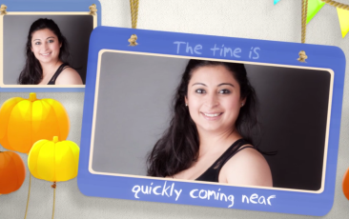 | Slide No. 4 (Mother Photograph)  (High Resolution : Minimum 800 x 800 pixel)  Please rename your photograph with the name of Slide 4  Send your photograph by E-mail

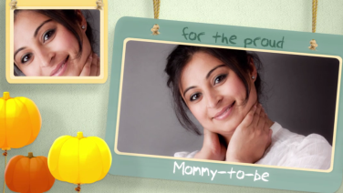 | Slide No. 5 (Mother Photograph)  (High Resolution : Minimum 800 x 800 pixel)  Please rename your photograph with the name of Slide 5  Send your photograph by E-mail

Slide No. 6 (Date, Time & Venue)
Date & Time :
on 25th December 2018
at 4.00 pm
Venue :
B/10, Sun Shine Apartments,
Opp. Shri Krishna Mandir, Kandivali (E), Mumbai – 67.

Video Music :
Same As

