Video No. P1405
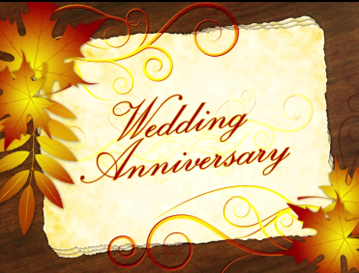 | Slide No. 1 (Anniversary)  Wedding Anniversary

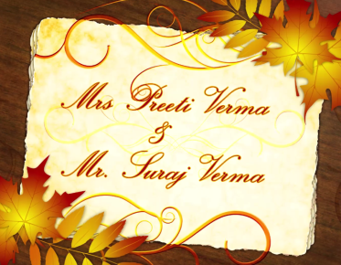 | Slide No. 2 (Couple Name)  Mrs. Preeti Verma  &  Mr. Suraj Verma

Slide No. 3 (Date)
on Oct 15th 2017

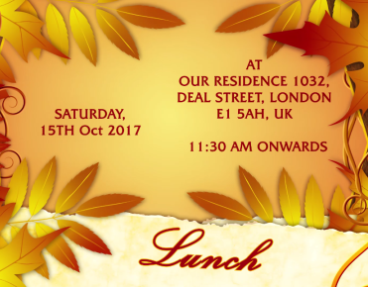 | Slide No. 4 (Date, Time & Venue)  Date & Time :  Saturday, 15th Oct 2017  11.30 am onwards  Lunch  Venue :  At Our Residence, 1032, Deal Street,  London, E1 5AH, UK

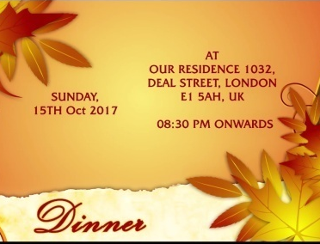 | Slide No. 5 (Date, Time & Venue)  Date & Time :  Saturday, 15th Oct 2017  08.30 pm onwards  Dinner  Venue :  At Our Residence, 1032, Deal Street,  London, E1 5AH, UK

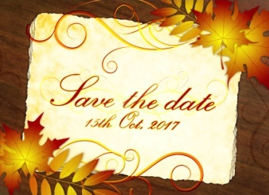 | Slide No. 6 (Save the date)  Save the date  15th Oct 2017

Video Music :
Same As

