Video No. P1404
Slide No. 1 (Couple Name & Year of Anniversary)
Mrs. & Mr. Rajeev Goel
5th Anniversary

Slide No. 2 (Date & Time)
Date & Time :
21st Jan 2018
11.00 am onwards

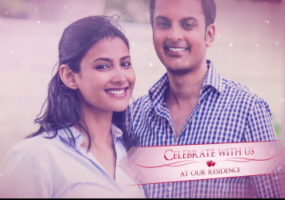 | Slide No. 3 (Couple Photograph)  (High Resolution : Minimum 800 x 800 pixel)  Please rename your photograph with the name of Slide 3  Send your photograph by E-mail  Celebrate with us

Slide No. 4 (Date & Venue)
Date :
Save The Date
21st Jan 2018
Venue :
Royal Banqueting Road, Opp. Mercedes Benz Showroom,
Kandivali (W), Mumbai – 400067.

Video Music :
Same As

