Video No. P1403
Slide No. 1 (Year of Anniversary)
25th Wedding Anniversary

Slide No. 2 (Year of Anniversary)
25 years of togetherness

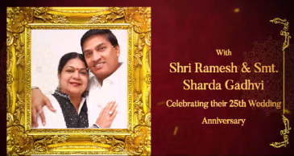 | Slide No. 3 (Couple Photograph, Couple Name & Wedding Year)  (High Resolution : Minimum 800 x 800 pixel)  Please rename your photograph with the name of Slide 3  Send your photograph by E-mail  Name :  Shri Ramesh & Smt. Sharda Gadhvi  Year :  Celebrating their 25th Wedding Anniversary

Slide No. 4 (Date, Time & Venue)
Date & Time :
Sunday, 5th March 2018
Party & Dinner – 8.00 pm onwards
Venue :
At Sairaj Party Hall
Ganesh Nagar, Kandivali (West), Mumbai - 67

Slide No. 5
Awaiting your welcome
Gadhvi Family

Video Music :
Same As

