Video No. P1402
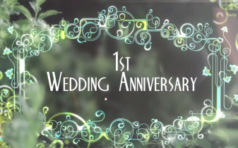 | Slide No. 1 (Year of Anniversary)  1st Wedding Anniversary

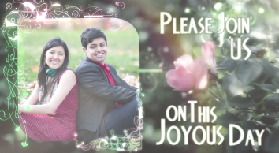 | Slide No. 2 (Couple Photograph)  (High Resolution : Minimum 800 x 800 pixel)  Please rename your photograph with the name of Slide 2  Send your photograph by E-mail

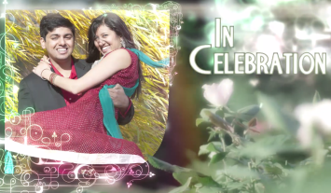 | Slide No. 3 (Couple Photograph)  (High Resolution : Minimum 800 x 800 pixel)  Please rename your photograph with the name of Slide 3  Send your photograph by E-mail

Slide No. 4 (Solo Photograph)
(High Resolution : Minimum 800 x 800 pixel)
Please rename your photograph with the name of Slide 4
Send your photograph by E-mail
of our 1st Wedding Anniversary

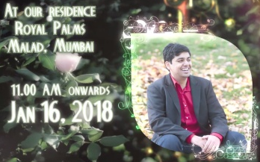 | Slide No. 5 (Solo Photograph)  (High Resolution : Minimum 800 x 800 pixel)  Please rename your photograph with the name of Slide 5  Send your photograph by E-mail  Venue :  At our residence,  Royal Palms, Malad, Mumbai  Time & Date :  11.00 am onwards  Jan 16, 2018

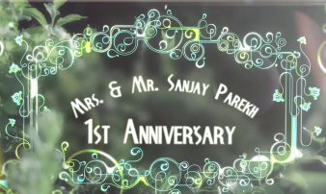 | Slide No. 6  Mrs. & Mr. Sanjay Parekh  1st Wedding Anniversary

Video Music :
Same As

