Video No. P1401
Slide No. 1 (Year of Anniversary & Name)
1st Wedding Anniversary
Mrs. & Mr. Anand Joshi

Slide No. 2 (Date)
05-03-2018

Slide No. 3 (Couple Photograph)
(High Resolution : Minimum 800 x 800 pixel)
Please rename your photograph with the name of Slide 3
Send your photograph by E-mail

Slide No. 4 (Couple Photograph)
(High Resolution : Minimum 800 x 800 pixel)
Please rename your photograph with the name of Slide 4
Send your photograph by E-mail

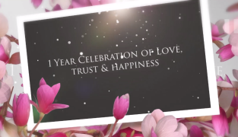 | Slide No. 5  1 Year Celebration of Love  Trust & Happiness

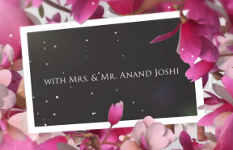 | Slide No. 6  with Mrs. & Mr. Anand Joshi

Slide No. 7 (Function Detail)
Date :
Sunday, 05th March 2018
Time :
Party & Dinner : 8.00 pm onwards
Venue :
At Royal Gardens, Tribhuvan Nagar,
Gemini Society, Khar, Mumbai

Slide No. 8
Awaiting your gracious presence

Slide No. 9
We need your blessings
Thank You

Video Music :
Same As or If any choice please send me Youtub Link by mail and Mention in form also.
Link :
https://www.youtube.com/watch?v=nIhijSP3MBc

