Video No. P 1303
Slide : 1
Thank you All

Slide : 2
Couple Photographs

Slide : 3
For attending our wedding

Slide : 4
You brought warmth to our lives

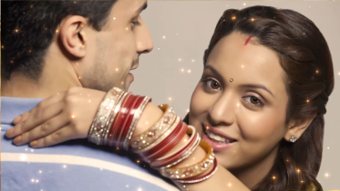 | Slide : 5  Couple Photographs

Slide : 6
Your gifts Appreciated

Slide : 7
You gave us a lasting Memory

Slide : 8
With lots of love

Slide : 8
Couple name
Ashika & Arnav

Video Music :
Same As or If any choice please send me Youtub Link by mail and Mention in form also.
Link :

