Video No. P 1203
Slide : 1
Love is Forever

Slide : 2 (Groom Solo Photograph)
(High Resolution : Minimum 800 x 800 pixel)
Please rename your photograph with the name of Slide 2
Send your photograph by E-mail

Groom name
Ajinkya

Slide : 3 (Bride Solo Photograph)
(High Resolution : Minimum 800 x 800 pixel)
Please rename your photograph with the name of Slide 3
Send your photograph by E-mail

Bride name
Shruti

Slide : 4 (Couple Photograph & couple name)
(High Resolution : Minimum 800 x 800 pixel)
Please rename your photograph with the name of Slide 3
Send your photograph by E-mail

Couple Name
Shruti - Ajinkya

Slide : 9 (Invitation Matter)
We Request the honor of your presence at the marriage of our daughter

Srushti to Ajinkya

Thursday, Jan 11. 2018
Eleven o’clock in the morning
Reception to follow

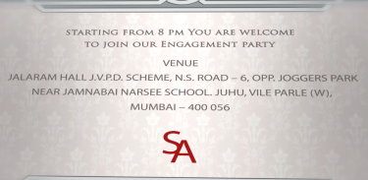 | Slide : 10 (Venue)  Starting from 8 pm you are welcome  To join our Engagement party  At  Jalaram hall, J.V.P.D. Scheme, N. S. Road, Opp. Joggers park, Near Jamnabai narsee School, Juhu, Vile Parle (W), Mumbai – 56.  First letter of Couple Name:  SA

Video Music :
Same As or If any choice please send me Youtub Link by mail and Mention in form also.
Link :

