Video No. P 1201
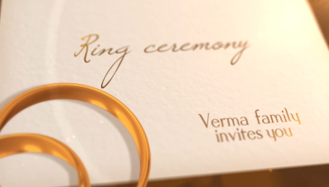 | Slide No. 1 (Ring Ceremony)  Family Name  Verma Family  Invites you

Slide No. 2
Couple Name
Shruti & Ronak

Slide No. 3
Couple Photograph
(High Resolution : Minimum 800 x 800 pixel)
Please rename your photograph with the name of Slide 1
Send your photograph by E-mail

Slide No. 4 (Function Detail)
Function Name
Ring Ceremony
Function Time :
At 6.30 pm
Function Date :
Saturday, 11.03.2018

Slide No. 5 (Function Detail)
Function Name
Sangeet
Function Time :
At 6.30 pm
Function Date :
Saturday 10.03.2018
Venue:
At Sunshine Resorts
Jodhpur Satellite Area
Ahemdabad, Gujarat.

Slide No. 6
Save The Date
11th march 2018

Video Music :
Same As or If any choice please send me Youtub Link by mail and Mention in form also.
Link :

