Video No. P 1106
Slide : 1
Couple Name
Geeta & Sanjay
Date
Jan 16, 2018

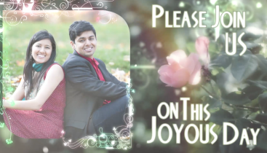 | Slide : 2  Please join us  On this joyous Day  Couple Photographs  (High Resolution : Minimum 800 x 800 pixel)  Please rename your photograph with the name of Slide 3  Send your photograph by E-mail

Slide : 3
In Celebration
(High Resolution : Minimum 800 x 800 pixel)
Please rename your photograph with the name of Slide 3
Send your photograph by E-mail

Slide : 4
Of our Love
Bride Photograph
(High Resolution : Minimum 800 x 800 pixel)
Please rename your photograph with the name of Slide 3
Send your photograph by E-mail

Slide : 5
Come Join us By
Save the Date
Jan 16,2018
Bride Photograph
(High Resolution : Minimum 800 x 800 pixel)
Please rename your photograph with the name of Slide 3
Send your photograph by E-mail

Slide : 6
Couple Name
Geeta & Sanjay
Date
Jan 16, 2018

Video Music :
Same As or If any choice please send me Youtub Link by mail and Mention in form also.
Link :

