Video No. P 1104
Slide : 1
Hello
This is the Story
of

Slide : 2
Two People in love
Couple name
Kartik - Kritika

Slide : 3
First Met:
08/08/2015
Place
Book Shop in Mumbai

Slide : 4
First Date:
15/08/2015
Place
Café coffee Day

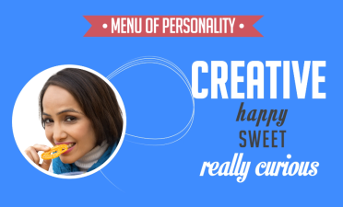 | Slide : 5  Menu of Personality  Bride Photograph  Creative  Happy Sweet  Really curious

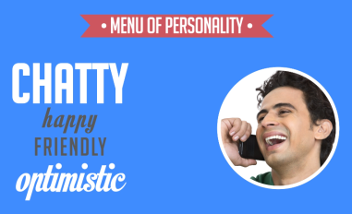 | Slide : 6  Menu of Personality  Groom Photograph  Chatty  Happy Friendly  optimistic

Slide : 7
Few years later

Slide : 8
The proposal

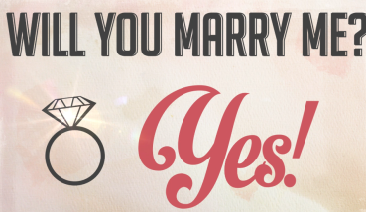 | Slide : 9  Will you marry me?  Yes!

Slide : 10
Save the date
09.09.2017
Couple Photograph
Hope to see you at our wedding

Video Music :
Same As or If any choice please send me Youtub Link by mail and Mention in form also.
Link :

