Video No. P 1102
Slide : 1
Couple Photograph

Slide : 2
Couple Name
Lucky & Kiara

Slide : 3
Groom name
Lucky

Slide : 4
Bride name
Kiara

Slide : 5
She said yes!

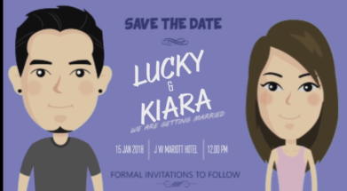 | Slide : 6  Save the Date  Lucky & Kiara  We are getting married  Date  15 jan 2018  Venue  J W Marriott Hotel  Time  12.00 pm  Formal invitation to follow

Video Music :
Same As or If any choice please send me Youtub Link by mail and Mention in form also.
Link :

