Video No. P 1035
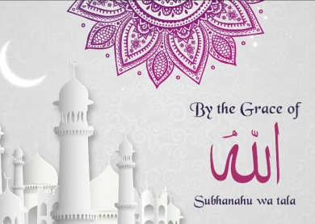 | Slide : 1  By the grace of  Subhanahu Wa tala

Slide : 2
And with the blessings of our parents
Groon Parents name
Mrs. & Mr. Ibrahim Ansari
Bride Parents Name
Mrs. & Mr. Abdul Hamid

Slide : 3
Couple Name
Aamir & Aalia

Slide : 4
Are blessed to be in love & ready to say
Qubool hai!

Slide : 5
Nikah
Monday, On 15th Dec,2017
After Namaz - e - asr

Slide : 6
Venue
At, Farida Wedding Hall
Juhu, Opp Bus Stop, Mumbai.

Slide : 7
Come, Shower your blessings upon us as we Embark on our journey of togetherness unto Eternity.

See you there.

Video Music :
Same As or If any choice please send me Youtub Link by mail and Mention in form also.
Link :
Same As

