Video No. P 1032
Slide : 1
Couple Name first Latter
FS
Add Quote as per your choice

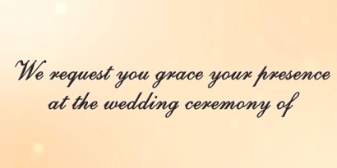 | Slide : 2  We request you grace your presence at the wedding ceremony of

Slide : 3
Couple Name
Farooq with Shabana

Slide : 4
Join the celebration of love of a lifetime in theirs life journey.

Slide : 5
With Blessings from
Mrs. Anwar Fatima & Mr. Naseem Ahmad
And
Mrs. Shahina Shafi & Late Shafiur Rahman

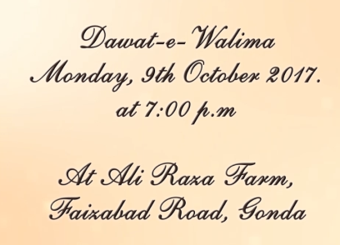 | Slide : 6 (Function Detail)  Dawat – E – Walima  Monday, 9th Octobor 2018  At 7.00 pm  At Ali Raza Farm, Faizabad Road, Gonda.

Slide : 7 (With Best compliments From)
Mrs. & Mr. Jamil Ahmad Khan
CMD, Samiah Group

Slide : 7
RSVP
Mrs. & Mr. Naseem Ahmad
CMD, SNGF Group
Mob. 9936940786

Video Music :
Same As or If any choice please send me Youtub Link by mail and Mention in form also.
Link :
Same As

