Video No. P 1029
Slide : 1
Couple Name
Anmol weds Parthi
Invitation

Slide : 2 (Couple Photograph)
(High Resolution : Minimum 800 x 800 pixel)
Please rename your photograph with the name of Slide 2
Send your photograph by E-mail

Slide : 3 (Function Detail)
Sangeet
Saturday, 17th February 2018
At or residence, 1032, Deal Street, London E1 SAH, UK.
7.30 pm onwards
With best compliments from
Purohit Family

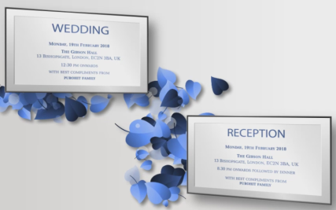 | Slide : 4 (Function Detail)  Wedding  Monday, 19th February 2018  At or residence, 1032, Deal Street, London E1 SAH, UK.  12.30 pm onwards  With best compliments from  Purohit Family  Reception  Monday, 19th February 2018  At or residence, 1032, Deal Street, London E1 SAH, UK.  8.30 pm onwards  With best compliments from  Purohit Family

Slide : 5
Save the date
19.02.2018

Video Music :
Same As or If any choice please send me Youtub Link by mail and Mention in form also.
Link :
Same As

