Video No. P 1024
Slide : 1 (Couple Name & Date)
Couple name
Nishita weds Piyush
Date :
11.03.2018

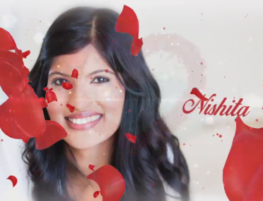 | Slide : 2 (Bride Photograph & Name)  (High Resolution : Minimum 800 x 800 pixel)  Please rename your photograph with the name of Slide 2  Send your photograph by E-mail  Bride name  Nishita

Slide : 3 (Groom Photograph & Name)
(High Resolution : Minimum 800 x 800 pixel)
Please rename your photograph with the name of Slide 3
Send your photograph by E-mail

Groom name
Piyush

Slide : 4 (Function detail)
Function name
Sangeet
Date
On Saturday, 10.03.2018
Venue
At banquets of Minnesota 6310 HWY 65 NE, Fridley, MN 55432, USA.
Time
7.00 pm onwards followed by cocktails and dinner

Slide : 5 (Function detail)
Function name
Wedding
Couple name
Nishita weds Piyush
Date
On Sunday, 11.03.2018, 12.30 pm
Venue
At banquets of Minnesota 6310 HWY 65 NE, Fridley, MN 55432, USA.
Time
8.00 pm onwards followed by dinner

Slide : 6 (Function detail)
Function name
Reception
Couple name
Nishita & Piyush
Date
On Sunday, 11.03.2018, 6.30 pm
Venue
At banquets of Minnesota 6310 HWY 65 NE, Fridley, MN 55432, USA.
Time
8.00 pm onwards followed by dinner

Slide : 7 (Save the date)
11.03.2018

Video Music :
Same As or If any choice please send me Youtub Link by mail and Mention in form also.
Link :
Same As

