Video No. P 1022
Slide : 1 (Family name)
Shrivastav Family
Invites You

Slide : 2 (couple name)
Ruhani - Rajeev

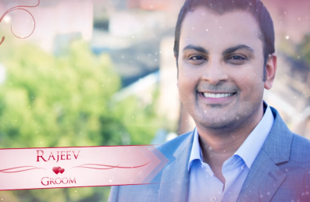 | Slide : 3 (Groom Photograph & name)  (High Resolution : Minimum 800 x 800 pixel)  Please rename your photograph with the name of Slide 3  Send your photograph by E-mail  Groom Name :  Rajeev  (If you are from bride side so first photo will come Bride photo and from groom side so first photo will come groom photo)

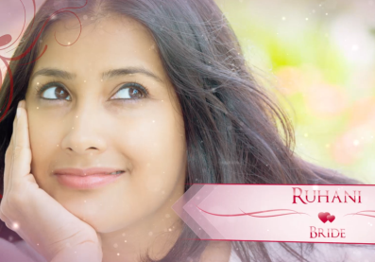 | Slide : 4 (Bride Photograph & name)  (High Resolution : Minimum 800 x 800 pixel)  Please rename your photograph with the name of Slide 3  Send your photograph by E-mail  Bride Name :  Ruhani

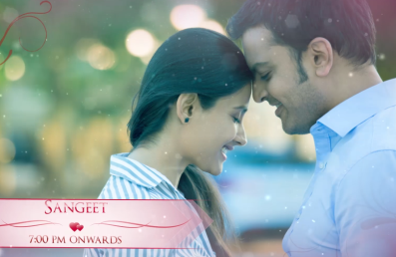 | Slide : 5 (Couple Photograph & Function detail)  (High Resolution : Minimum 800 x 800 pixel)  Please rename your photograph with the name of Slide 3  Send your photograph by E-mail  Function Detail  Sangeet  7.00 pm onwards

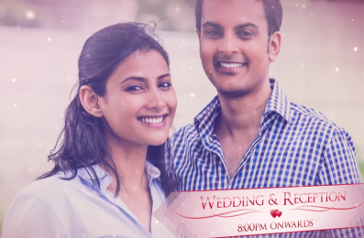 | Slide : 6 (Couple Photograph & Function detail)  (High Resolution : Minimum 800 x 800 pixel)  Please rename your photograph with the name of Slide 3  Send your photograph by E-mail  Function Detail  Wedding & reception  8.00 pm onwards

Slide : 7 (Save the Date & Venue detail)
Save the Date
21st jan. 2018

Venue
Royal banqueting Road, Opp. Mercedes Benz Showroom, Kandivali (W), Mumbai – 67.

Video Music :
Same As or If any choice please send me Youtub Link by mail and Mention in form also.
Link :
Same As

