Video No. P 1021
Slide No. 1 (Wedding Invitation)
Couple Name
Akshar and Mahi
Date
11.3.2018

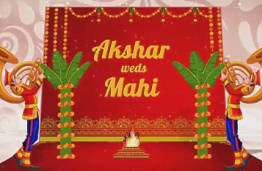 | Slide No. 2 (Couple Name)  Akshar weds Mahi

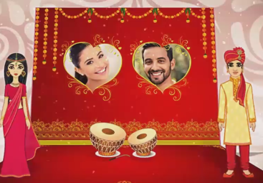 | Slide No. 3 (Bride & Groom Solo Photograph)  (High Resolution : Minimum 800 x 800 pixel)  Please rename your photograph with the name of Slide 3  Send your photograph by E-mail

Slide No. 4 (Function Detail)
Parents Name
Mrs. Asha Adanani & Mr. Suresh Adanani
Invites you for
Function Name
Sangeet
Function Date :
Friday 26th januray 2018
Function Time :
At 7.00 pm onwards
Venue:
The Al Massa Grand ball Room, The Hotel Zayed Road, Dubai, UAE.

Slide No. 5 (Function Detail)
Function Name
Wedding
Function Date :
Saturday 27th januray 2018
Function Time :
At 11.00 am onwards
Venue:
The Al Massa Grand ball Room, The Hotel Zayed Road, Dubai, UAE.

Slide No. 6 (Function Detail)
Function Name
Reception
Function Date :
Saturday 27th januray 2018
Function Time :
At 6.00 pm onwards
Venue:
The Al Massa Grand ball Room, The Hotel Zayed Road, Dubai, UAE.

Slide No. 7 (Save the date)
Couple Name
Akshar and Mahi
Save the Date
11.3.2018

Video Music :
Same As or If any choice please send me Youtub Link by mail and Mention in form also.
Link :
https://www.youtube.com/watch?v=nIhijSP3MBc

