Video No. P 1019
Slide No. 1 (couple Name)
Riana weds Priyen

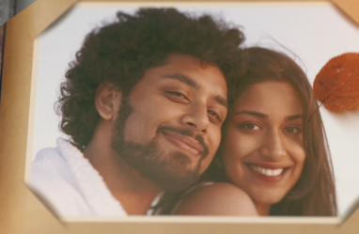 | Slide No. 2 (Couple Photograph)  (High Resolution : Minimum 800 x 800 pixel)  Please rename your photograph with the name of Slide 1  Send your photograph by E-mail

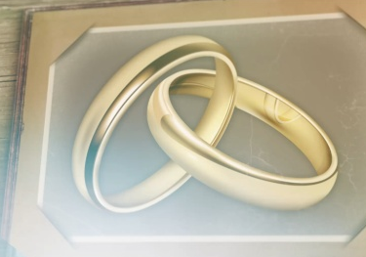 | Slide No. 3  If you want to add your photograph instead of this image can be possible.  Mail me your high resolution photos

Slide No. 4 (Function Detail)
Function Name
Ring Ceremony
Function Time :
At 5.00 pm
Function Date :
22nd October 2018
Venue:
At Royal Palms, Malad, Mumbai.

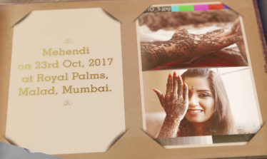 | Slide No. 5 (Function Detail)  Function Name  Mehendi  Function Time :  At 6.00 pm  Function Date :  23rd October 2018  Venue:  At Royal Palms, Malad, Mumbai.  If you want to add your photograph instead of this image can be possible.  Mail me your high resolution photos

Slide No. 6
If you want to add your photograph instead of this image can be possible.
Mail me your high resolution photos

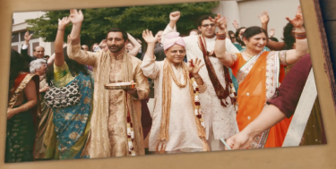 | Slide No. 7  If you want to add your photograph instead of this image can be possible.  Mail me your high resolution photos

Slide No. 8 (Function Detail)
Function Name
Sangeet
Function Time :
At 8.00 pm
Function Date :
23rd October 2018
Venue:
At Royal Palms, Malad, Mumbai.

Slide No. 9 (Function Detail)
Function Name
Sangeet
Function Time :
At 8.00 pm
Function Date :
23rd October 2018
Venue:
At Royal Palms, Malad, Mumbai.

Slide No. 10 (Function Detail)
Function Name
Wedding Ceremony
Function Time :
At 10.00 am
Function Date :
25th October 2018
Venue:
At J W Marriott Hotel,

Video Music :
Same As or If any choice please send me Youtub Link by mail and Mention in form also.
Link :
https://www.youtube.com/watch?v=nIhijSP3MBc

