Video No. 1014
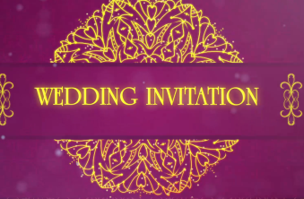 | Slide No. 1  Wedding Invitation

Slide No. 2
Couple Name
Roshan weds Roshini

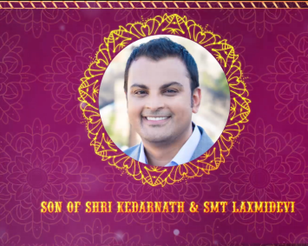 | Slide No. 3 (Groom Photograph & Parents Name)  Groom Photograph  (If you are from bride side so first photo will come Bride photo and from groom side so first photo will come groom photo)  (High Resolution : Minimum 800 x 800 pixel)  Please rename your photograph with the name of Slide 3  Send your photograph by E-mail  Groom parents Name  Son of Shri Kedarnath & Smt. Laxmidevi

Slide No. 4 (Bride Photograph & Parents Name)
Bride Photograph
(High Resolution : Minimum 800 x 800 pixel)
Please rename your photograph with the name of Slide 3
Send your photograph by E-mail

Bride parents Name
Daughter of Shri Tribhuvan & Smt. Sharda

Slide No. 5 (Function Detail)
Function Name
Mehendi
Date :
Sunday 21st Jan 2018
Time:
7.00 pm onwards
Venue :
Vivanta By Taj – Gurgaon
Plot No. 1, Sector 44, Gurgaon.

Slide No. 6 (Function Detail)
Function Name
Sangeet
Date :
Monday 22nd Jan 2018
Time:
7.00 pm onwards
Venue :
Vivanta By Taj – Gurgaon
Plot No. 1, Sector 44, Gurgaon.

Slide No. 7 (Function Detail)
Function Name
Wedding
Date :
Tuesday 23rd Jan 2018
Time:
11.00 am onwards
Venue :
Vivanta By Taj – Gurgaon
Plot No. 1, Sector 44, Gurgaon.

Slide No. 8 (Function Detail)
Function Name
Reception
Date :
Tuesday 23rd Jan 2018
Time:
6.00 pm onwards
Venue :
Vivanta By Taj – Gurgaon
Plot No. 1, Sector 44, Gurgaon.

Slide No. 9 (Couple Photograph)
(High Resolution : Minimum 800 x 800 pixel)
Please rename your photograph with the name of Slide 3
Send your photograph by E-mail

Video Music :
Same As or If any choice please send me Youtub Link by mail and Mention in form also.
Link :
https://www.youtube.com/watch?v=nIhijSP3MBc

