Video No. 1013
Slide No. 1 (Parents Name)
Mr. & Mrs. Verma
Invites you

Slide No. 2
For the wedding of

Slide No. 3 (couple name)
Shiv & Kriti

Slide No. 4
A handsome Groom

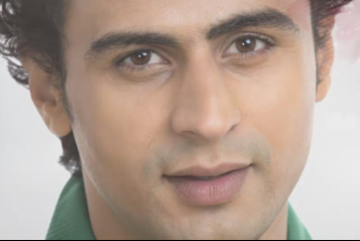 | Slide No. 5 (Groom Photograph)  (If you are from bride side so first photo will come Bride photo and from groom side so first photo will come groom photo)  (High Resolution : Minimum 800 x 800 pixel)  Please rename your photograph with the name of Slide 5  Send your photograph by E-mail

Slide No. 6
A beautiful bride

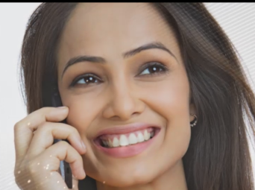 | Slide No. 7 (Bride Photograph)  (High Resolution : Minimum 800 x 800 pixel)  Please rename your photograph with the name of Slide 5  Send your photograph by E-mail

0
Slide No. 8
A wonderful beginning

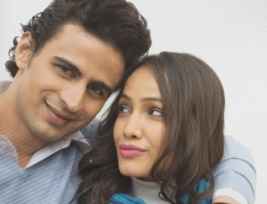 | Slide No. 9 (Couple Photograph)  (High Resolution : Minimum 800 x 800 pixel)  Please rename your photograph with the name of Slide 9  Send your photograph by E-mail

Slide No. 10 (Function Detail)
Sangeet
On Wednesday, February 21st 2018
Please join us for dinner at 7.30 pm
Venue : St. Charles Convention Centre
1 Convention Centre Plaza Charles, Mo. 63303.

Slide No. 11 (Function Detail)
Wedding
On Thursday, February 22nd 2018
Please join us at 11.30 am
Venue : St. Charles Convention Centre
1 Convention Centre Plaza Charles, Mo. 63303.

Slide No. 12 (Function Detail)
Reception
On Thursday, February 22nd 2018
Please join us at 6.30 pm followed by dinner
Venue : St. Charles Convention Centre
1 Convention Centre Plaza Charles, Mo. 63303.

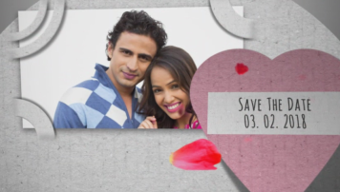 | Slide No. 13 (Save The date & Couple Photograph)  Couple Photograph  (High Resolution : Minimum 800 x 800 pixel)  Please rename your photograph with the name of Slide 13  Send your photograph by E-mail  Save The date  03.02.2018

Video Music :
Same As or If any choice please send me Youtub Link by mail and Mention in form also.
Link :
https://www.youtube.com/watch?v=nIhijSP3MBc

