Video No.: P 1011
Slide : 1 (Solo Photograph)
(High Resolution : Minimum 800 x 800 pixel)
Please rename your photograph with the name of Slide 1
Send your photograph by E-mail

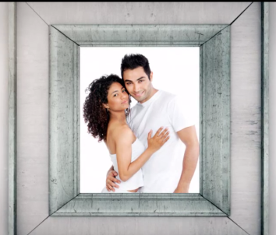 | Slide : 2 (Couple Photograph)  (High Resolution : Minimum 800 x 800 pixel)  Please rename your photograph with the name of Slide 2  Send your photograph by E-mail

Slide : 3 (Solo Photograph)
(High Resolution : Minimum 800 x 800 pixel)
Please rename your photograph with the name of Slide 3
Send your photograph by E-mail

Slide : 4 (Couple Name)
Piyush & Nishita
request the honour of your presence at their marriage

Slide : 5 (Function Date, Time & Venue )
Saturday, 11th of March 2018
The ceremony will be held at:
Della Resorts, Lonavala
Reception to follow at:
Sunshine Tower, Mumbai.

Video Music :
Same As or If any choice please send me Youtub Link by mail and Mention in form also.
Link :
https://www.youtube.com/watch?v=nIhijSP3MBc

