Video No.: P 1010
Slide : 1 (Couple Photograph)
(High Resolution : Minimum 800 x 800 pixel)
Please rename your photograph with the name of Slide 1
Send your photograph by E-mail
Wedding Invitation

Slide : 2 (Couple Name)
Ankush
Supriya

Slide : 3 (Groom Parents Name)
S/o. Hansaben Ajmera & Hasmukhlal M. Ajmera

Slide : 4 (Bride Parents Name)
D/o. Parulben Bhansali & Dhiren Bhansali

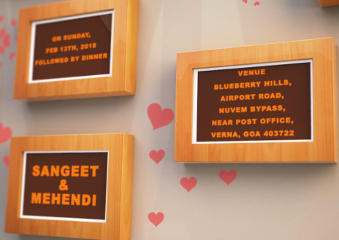 | Slide : 5 (Function Detail)  Function Name, Date, Time & Venue  Sangeet & Mehendi  on Saturday 13th Feb 2018  6.30 pm onwards followed by dinner  At Blue Berry Hill,  Airport Road, Nuvem Bypass, Near Post Office, Venra,  Goa - 403722

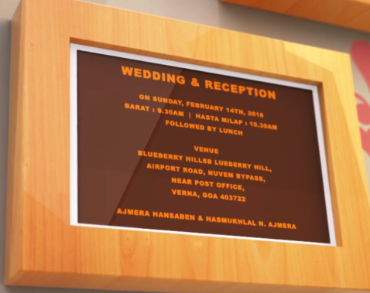 | Slide : 6 (Function Detail)  Function Name, Date, Time & Venue  Wedding & Reception  on Sunday 14th Feb 2018  Baraat : 9.30 am | Hast Melap : 10.30 am  Reception 12.00 pm onwards followed by lunch  At Blue Berry Hill,  Airport Road, Nuvem Bypass, Near Post Office, Venra,  Goa - 403722  Hansaben Ajmera & Hasmukhlal M. Ajmera

Slide : 7 (Save the date)
Date :
14.02.2018

Video Music :
Same As or If any choice please send me Youtub Link by mail and Mention in form also.
Link :
https://www.youtube.com/watch?v=nIhijSP3MBc

