Video No.: P 1009
Slide : 1 (Wedding Invitation)
Couple Name
Reema & Shivay

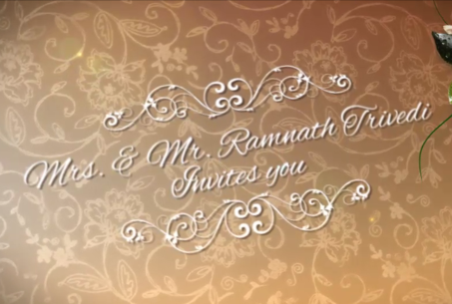 | Slide : 2  Mr. & Mrs. Ramnath Trivedi  Invites you

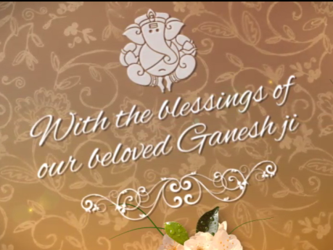 | Slide : 3  With the blessings of  our beloved Ganeshji

Slide : 4 (Couple Photograph & Name)
(High Resolution : Minimum 800 x 800 pixel)
Please rename your photograph with the name of Slide 4
Send your photograph by E-mail
Couple Name
Reema weds Shivay

Slide : 5 (Wedding Date & Time)
Date & Time
on 14th Feb, 2018, Sunday
11.00 am onwards

Slide : 6 (Function Detail)
Function Name, Date, Time & Venue
Mehendi
at 6.30 pm, on Friday, 12.02.2018
At Della Resorts, Panchgani

Slide : 7 (Function Detail)
Function Name, Date, Time & Venue
Sangeet
at 8.30 pm, on Saturday, 13.02.2018
At Della Resorts, Panchgani

Slide : 8 (Function Detail)
Function Name, Date, Time & Venue
Wedding
at 7.30 pm, on Sunday, 14.02.2018
At Della Resorts, Panchgani

Slide : 9 (Function Detail)
Function Name, Date, Time & Venue
Reception
at 8.30 pm, on Sunday, 14.02.2018
At Della Resorts, Panchgani

Slide : 10 (Save the date)
Date :
Feb 14, 2018

Video Music :
Same As or If any choice please send me Youtub Link by mail and Mention in form also.
Link :
https://www.youtube.com/watch?v=nIhijSP3MBc

