Video No. : P 1008
Slide : 1 (Royal Wedding)
Couple Name
Priyanka & Ayushman

Slide : 2 (Invitation)
Couple Initial
PA
Parents Name :
Mr. & Mrs. Sahil Verma
Invites you to the grand wedding of

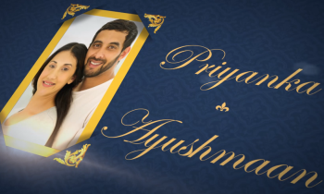 | Slide : 3 (Couple Name & Photograph)  Couple Photograph(High Resolution : Minimum 800 x 800 pixel)  Please rename your photograph with the name of Slide 2  Send your photograph by E-mail  Couple Name  Priyanka & Ayushman

Slide : 4 (Function Detail)
Function Name, Date, Time & Venue
Ring Ceremony
On 29th August 2018
At 5.00 pm onwards
At Sunrise Party Hall, Dahisar, Mumbai.
Photo : Same as Or Your pic (Solo or couple) As per your choice.

Slide : 5 (Function Detail)
Function Name, Date, Time & Venue
Mehendi
On 5th August 2018
At 4.00 pm onwards
At Sunrise Party Hall, Dahisar, Mumbai.
Photo : Same as Or Your pic (Solo or couple) As per your choice.

Slide : 6 (Function Detail)
Function Name, Date, Time & Venue
Sangeet
On 6th August 2018
At 7.00 pm onwards
At Sunrise Party Hall, Dahisar, Mumbai.
Photo : Same as Or Your pic (Solo or couple) As per your choice.

Slide : 7 (Function Detail)
Function Name, Date, Time & Venue
Wedding & Reception
On 7th August 2018
At 12.30 pm onwards followed by Lunch
At Sunrise Party Hall, Dahisar, Mumbai.

Slide : 7 (Couple Photograph)
(High Resolution : Minimum 800 x 800 pixel)
Please rename your photograph with the name of Slide 2
Send your photograph by E-mail

Slide : 7 (Save the date)
Date :
07.03.2018

Video Music :
Same As or If any choice please send me Youtub Link by mail and Mention in form also.
Link :
https://www.youtube.com/watch?v=nIhijSP3MBc

