Video No. P 1007
Slide : 1 (Our Wedding Invirtation)
Save the Date :
05 March 2018

Slide : 2 (Parents Name)
Mr. Ravi Gaur & Mrs. Jyoti Gaur
Introduces

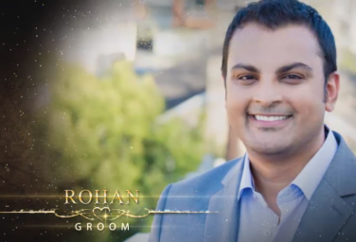 | Slide : 3 (Groom Photograph & Name)  (High Resolution : Minimum 800 x 800 pixel)  Please rename your photograph with the name of Slide 3  Send your photograph by E-mail  Groom Name :  Rohan  (If you are from bride side so first photo will come Bride photo and from groom side so first photo will come groom photo)

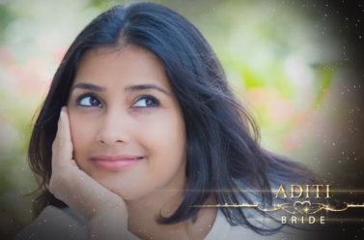 | Slide : 4 (Bride Photograph & Name)  (High Resolution : Minimum 800 x 800 pixel)  Please rename your photograph with the name of Slide 4  Send your photograph by E-mail  Groom Name :  Aditi

Slide : 5 (Function Detail)
Function Name
Sangeet
Function Date :
On Sunday 11.03.2017
Function Time :
At 12.30 pm
Venue:
At Blueberry Hills, Airport Road, Nuvam Baypass, Near Post Office, Goa.

Slide : 6 (Function Detail)
Wedding Ceremony of
Couple Name
Rohan & Aditi
Function Date :
05.03.2018 Sunday
Function Time :
Hast Melap 12.30 pm
Venue:
At Blueberry Hills, Airport Road, Nuvam Baypass, Near Post Office, Goa.

Video Music :
Same As or If any choice please send me Youtub Link by mail and Mention in form also.
Link :
Same As

